**DAILY ONLINE ACTIVITIES SUMMARY**

|  |  |  |  |  |
| --- | --- | --- | --- | --- |
| **Date:** | 13/07/2020 | **Name:** | JASLINE SHARON TAURO | |
| **Sem & Sec** | 4th sem,  A Section | **USN:** | 4AL18CS029 | |
| **Online Test Summary** | | | | |
| **Subject** | MICROCONTROLLER AND EMBEDDED SYSTEMS | | | |
| **Max. Marks** | 30 | **Score** | N/A | |
| **Certification Course Summary** | | | | |
| **Course** | INTRODUCTION TO HTML5 | | | |
| **Certificate Provider** | Coursera | **Duration:** | | 3 hrs |
| **Coding Challenges** | | | | |
| **Problem Statement:**  Write a Java Program to find the duplicate characters in a string. | | | | |
| **Status:** | | Executed | | |
| **Uploaded the report in GitHub** | | YES | | |
| **If yes Repository name** | | <https://github.com/jaslinesharontauro/JAVA_Prgms> | | |
| **Uploaded the report in slack** | | YES | | |

**ONLINE TEST DETAILS:**

**Today we had assessment on the subject MICROCONTROLLER AND EMBEDDED SYSTEMS. There were total 4 number of questions of 10 marks each out of which we had to attempt 3 questions. The test was Descriptive type.**

**CERTIFICATION COURSE DETAILS:**

#### Today I continued the course “INTRODUCTION TO HTML5” by Coursera. Today I learnt about The Document Object Model. I have completed week1 portion of this course.

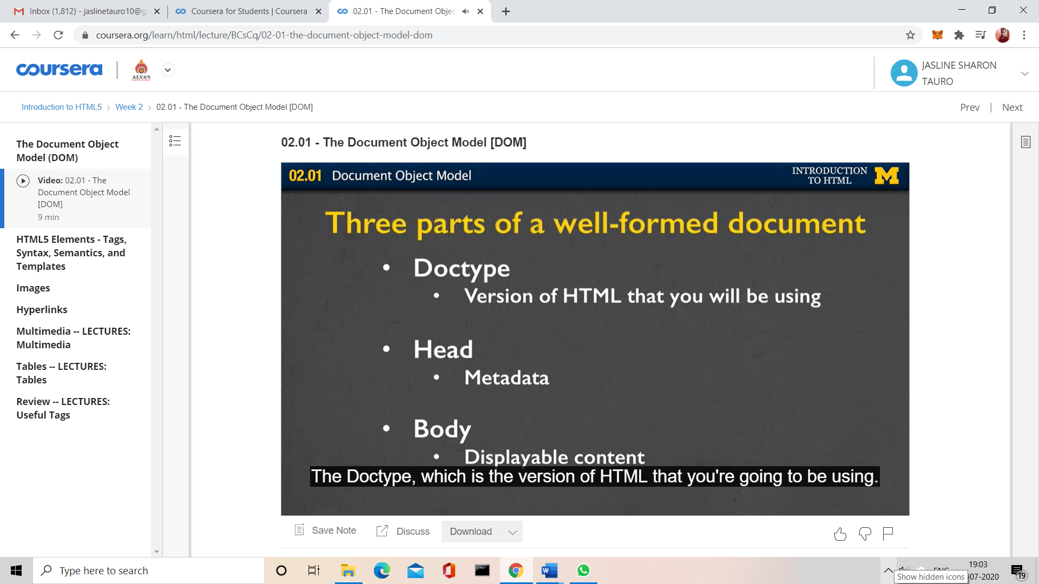

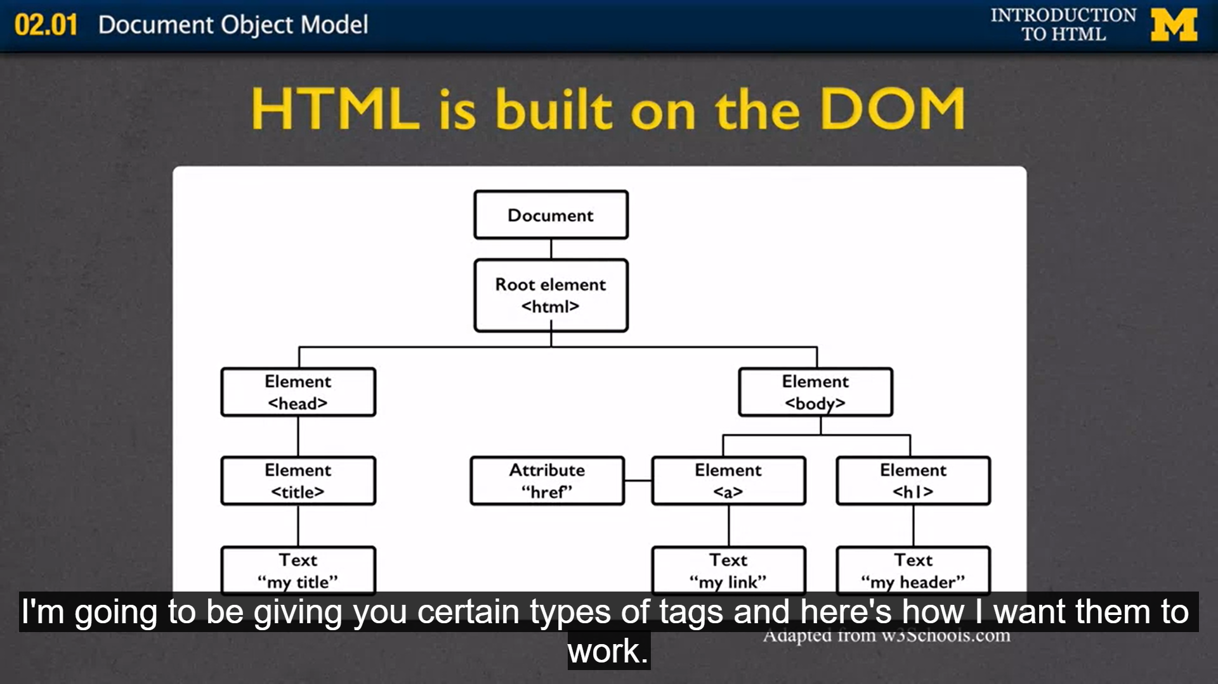

CODING CHALLENGES:

Problem Statement:

Write a Java Program to find the duplicate characters in a string.

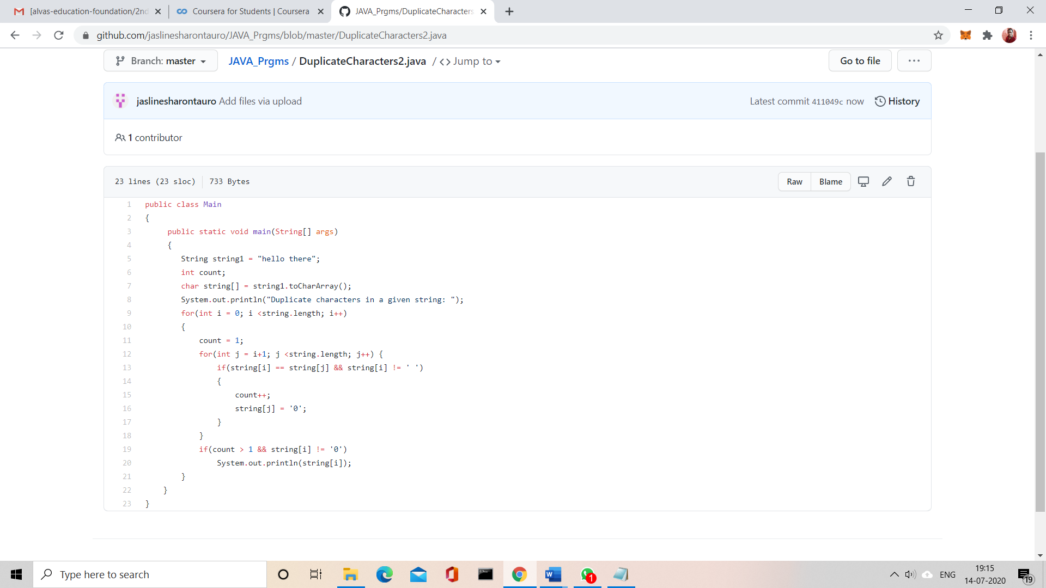

Solution uploaded in GitHub